Optimized Gradient Boosting Accuracy: 1.0
Optimized Weighted F1-score: 1.0

Classification report:
precision recall f1-score support

Adelie 1.00 1.00 1.00 30
Chinstrap 1.00 1.00 1.00 14
Gentoo 1.00 1.00 1.00 25

accuracy 1.00 69
macro avg 1.00 1.00 1.00 69
weighted avg 1.00 1.00 1.00 69

Confusion matrix:
[[30 0 0]
[ 0 14 0]
[ 0 0 25]]

Baseline prediction summary:
Number of test records: 69
Number predicted as target class: 25
Percentage predicted as target class: 0.36231884057971014
Average predicted probability for target class: 0.36212610738249007

Condition Seed Sample_Size Target_Class_Predictions \
0 Baseline 42 100 41
1 Baseline 43 100 35
2 Baseline 44 100 34
3 Baseline 45 100 36
4 Baseline 46 100 37

Target_Class_Prediction_Rate Average_Target_Class_Probability
0 0.41 0.394619
1 0.35 0.354710
2 0.34 0.344817
3 0.36 0.359584
4 0.37 0.366944

Simulation DataFrame shape: (30, 6)

Runs per condition:
Condition
Baseline 10
Scenario 1 10
Scenario 2 10
Name: count, dtype: int64

Simulation comparison table:
Condition Mean_Prediction_Rate Std_Prediction_Rate Min_Prediction_Rate \
0 Baseline 0.361 0.049989 0.28
1 Scenario 1 0.361 0.049989 0.28
2 Scenario 2 0.361 0.049989 0.28

Max_Prediction_Rate Mean_Probability
0 0.43 0.360644
1 0.43 0.360644
2 0.43 0.360644

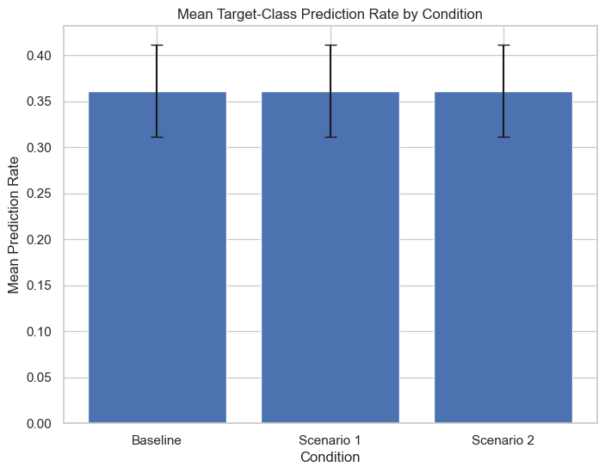
Selected feature: body_mass_g
Sensitivity values: [3300. 3825. 4350. 4875. 5400.]

Sensitivity results (head):
Feature_Value Seed Target_Class_Prediction_Rate \
0 3300.0 101 0.32
1 3300.0 102 0.39
2 3300.0 103 0.41
3 3300.0 104 0.33
4 3300.0 105 0.29

Average_Target_Class_Probability
0 0.331986
1 0.380270
2 0.394469
3 0.338610
4 0.311930

Sensitivity summary table:
Feature_Value Mean_Prediction_Rate Std_Prediction_Rate Mean_Probability
0 3300.0 0.348 0.0502 0.351453
1 3825.0 0.348 0.0502 0.351453
2 4350.0 0.348 0.0502 0.351453
3 4875.0 0.348 0.0502 0.351453
4 5400.0 0.348 0.0502 0.351453

